**SQL DML (FROM 3.3)**

**FETCH THE VALUES FROM A CURSOR:**

DECLARE

CURSOR c_emp_cursor IS

SELECT EmployeeID, LastName FROM employ

WHERE DepartmentID = 103;

v_empno employ.EmployeeID%TYPE;

v_lname employ.LastName%TYPE;

BEGIN

OPEN c_emp_cursor;

LOOP

FETCH c_emp_cursor INTO v_empno, v_lname;

EXIT WHEN c_emp_cursor%NOTFOUND;

DBMS_OUTPUT.PUT_LINE (v_empno || ' ' || v_lname);

END LOOP;

CLOSE c_emp_cursor;

END;

**TABLE:**

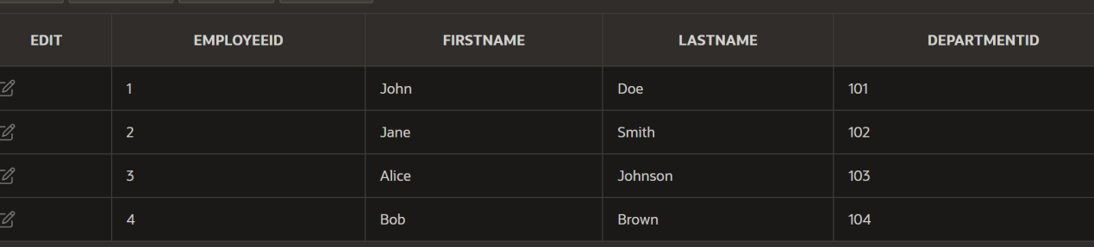

**OUTPUT:**

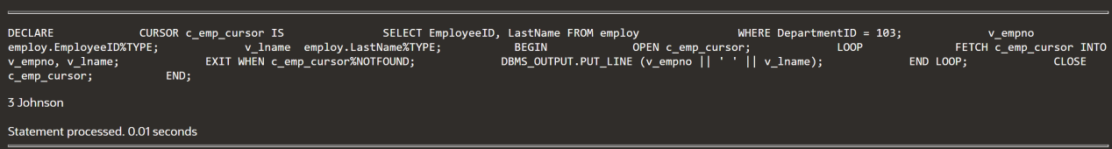

**FETCH VALUES FROM A RECORD:**

DECLARE

CURSOR c_emp_cursor IS

SELECT EmployeeID, LastName FROM employ

WHERE DepartmentID = 101;

v_emp_record c_emp_cursor%ROWTYPE;

BEGIN

OPEN c_emp_cursor;

LOOP

FETCH c_emp_cursor INTO v_emp_record;

EXIT WHEN c_emp_cursor%NOTFOUND;

DBMS_OUTPUT.PUT_LINE (v_emp_record.EmployeeID || ' ' ||v_emp_record.LastName);

END LOOP;

CLOSE c_emp_cursor;

END;

**TABLE:**

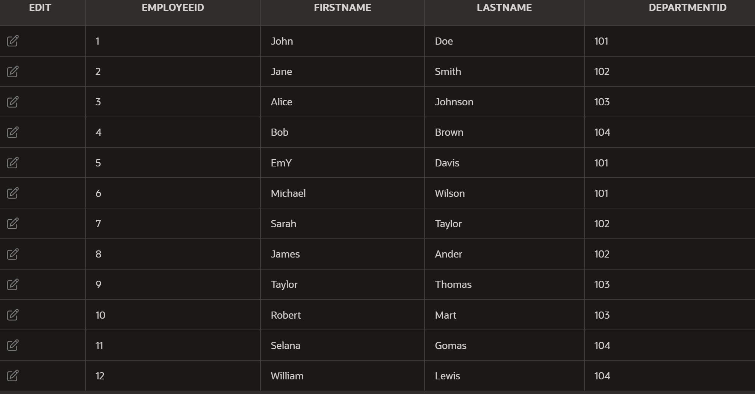

**OUTPUT:**

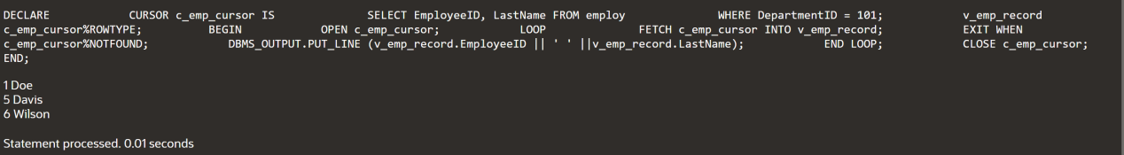

**USING %ROWCOUNT AND %NOTFOUND ATTRIBUTES:**

DECLARE

CURSOR c_emp_cursor IS

SELECT EmployeeID, LastName FROM employ

WHERE DepartmentID =103;

v_emp_record c_emp_cursor%ROWTYPE;

BEGIN

OPEN c_emp_cursor;

LOOP

FETCH c_emp_cursor INTO v_emp_record;

EXIT WHEN c_emp_cursor%ROWCOUNT > 10 OR c_emp_cursor%NOTFOUND;

DBMS_OUTPUT.PUT_LINE (v_emp_record.EmployeeID || ' ' ||

v_emp_record.LastName);

END LOOP;

CLOSE c_emp_cursor;

END;

**TABLE:**

**OUTPUT:**

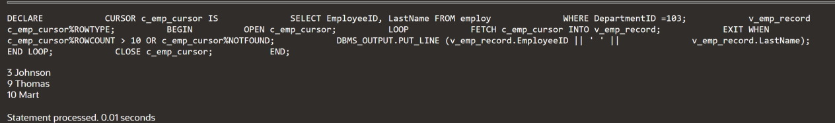

**USING A CURSOR FOR LOOP:**

DECLARE

CURSOR c_emp_cursor IS

SELECT EmployeeID, LastName FROM employ

WHERE DepartmentID = 101;

BEGIN

FOR emp_record IN c_emp_cursor

LOOP

DBMS_OUTPUT.PUT_LINE (emp_record.EmployeeID || ' ' ||

emp_record.LastName);

END LOOP;

END;

**OUTPUT:**

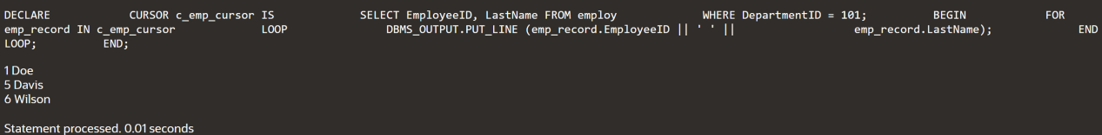

**USING A CURSOR FOR LOOP WITH SUBQUERIES:**

DECLARE

CURSOR c_emp_cursor IS

SELECT EmployeeID, LastName FROM employ

WHERE DepartmentID = 104;

BEGIN

FOR emp_record IN (SELECT EmployeeID, LastName FROM

employ WHERE DepartmentID = 104)

LOOP

DBMS_OUTPUT.PUT_LINE (emp_record.EmployeeID|| ' ' ||

emp_record.LastName);

END LOOP;

END;

**OUTPUT:**

